# Demotic

## Taught by Foy Scalf

## Notes by Minh-Tâm Trinh

*Note:* Throughout, I use #/* to mean h/t with a carat underneath.

**5/7/2024**

**1. Introduction to Demotic and How to Study It**

- periods of Demotic:

pre-Ptolemaic: 700 to 300 BCE

Ptolemaic: 300 BCE to 30 CE

Roman: 30 CE till the Coptic era

- introductory reference:

Johnson, [*Thus Wrote ’Onchsheshonqy: An Introductory Grammar of Demotic*](https://isac.uchicago.edu/sites/default/files/uploads/shared/docs/saoc45.pdf)

- in-depth references, esp. for dictionaries/sign lists:

Erichsen, *Demotisches Glossar* (EG)

The Chicago Demotic Dictionary (CDD)

- Erichsen has a list of signs (with their uses), grouped by SHAPE

- due to ligatures, there is no one-to-one correspondence between hieroglyphs and demotic signs

- El-Aguizy’s *Palaeographical Study of Demotic Papyri* assumes you already know the hieroglyphs corresponding to the demotic signs you need

- a tool in progress: the Demotic Palaeographic Database Project (DPDP)

- the greatest Demotists ever:

Karl-Theodor Zauzich

Wilhelm Spiegelberg

Janet H. Johnson

[greatest living Demotist]??

- main rule when learning signs: don’t get locked into a single spelling because variation is the norm

- “Ancient scribes also struggled [with common words spelled in unusual ways], and we know this, because when they try to copy these words or explain them, we can see that they’re having trouble…”

- Demotic is both a script and a phase of the Egyptian language

- Demotic emerged from the culture of the Saite, or Twenty-Sixth, Dynasty in northern / Lower Egypt

- during the time when Demotic emerged, southern / Upper Egypt used “Abnormal / Cursive Hieratic” script, but as the Saites established control over the country, Demotic became the administrative language throughout Egypt

- also known as “Enchorial” in the era of Champollion and Young

- Demotic literature:

Instructions of ’Onchsheshonqy ( = focus of Johnson’s book)

Tale of Setna and the Mummies (Setna I)

Tale of Setna and Si-Osire (Setna II)

Tale of Amasis and the Skipper

The Swallow and the Sea

The Myth of the Sun’s Eye

Demotic Chronicle

- 95% of published Demotic texts are NOT transcribed into hieroglyphs like those below; the exceptions tend to be those from the early periods (Achaemenid or Saite):

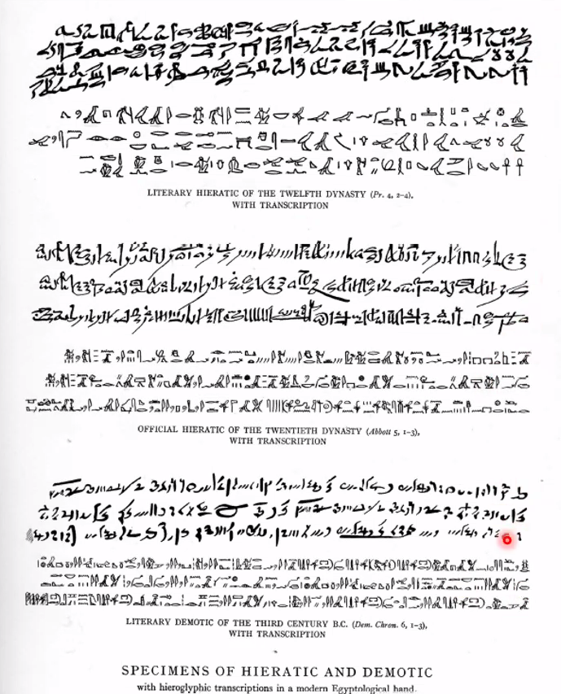

- Demotic still has phonograms, logo/ideograms, and determinatives

- Compare to Johnson’s “alphabet”:

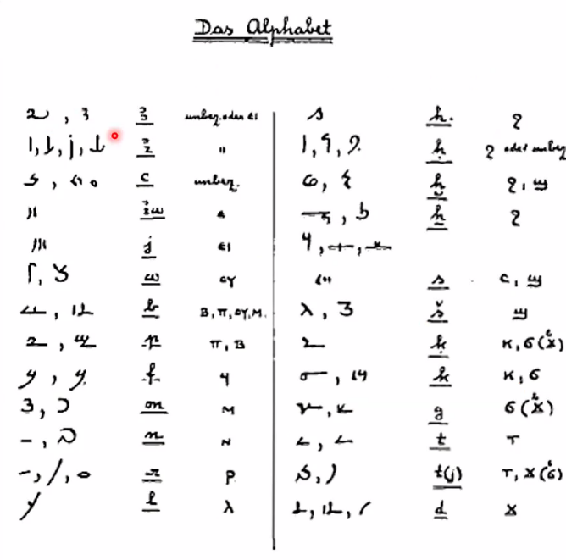

- as in Late Egyptian, the script shows significant reduplication of phonograms

- some recurring determinatives: the “divine determinative”, the one for bad things, the one for water, the phallus (!) for male things

- “Every time you get to the end of [an entry in] the Chicago Demotic Dictionary, and it says, ‘See Erichsen’, you go, ‘Ack!’”

- the feminine ending remains -t, but often they leave it out

- David Reese: Which pronunication to use in this class, since he comes from a background in Bohairic Coptic? Foy: Demotic is very close in grammatical structure to Coptic, so much so that early publications often listed Coptic translations next to Demotic texts; nonetheless, we stick to the conventional Egyptological pronunciations, in part because if we used Coptic ones then there would be confusion over dialects

- the main scholarly attempt to reconstruct the pronunciation of Egyptian: Joseph Osing, *Die Nominalbildung des Ägyptischen*

**5/14/2024**

**2. The Demotic sDm=f**

- Once more, the Demotic uniliterals:

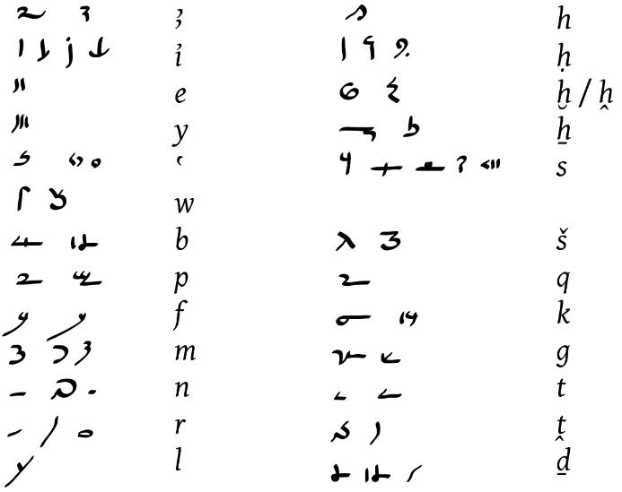

- Mary: What do you call T? Foy: “Tall T”

- why don’t we usually transcribe into Demotic? consider:

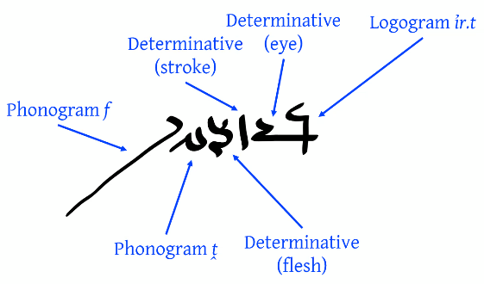

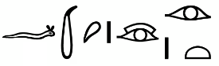

ir.t=f

- the basic nominal declension:

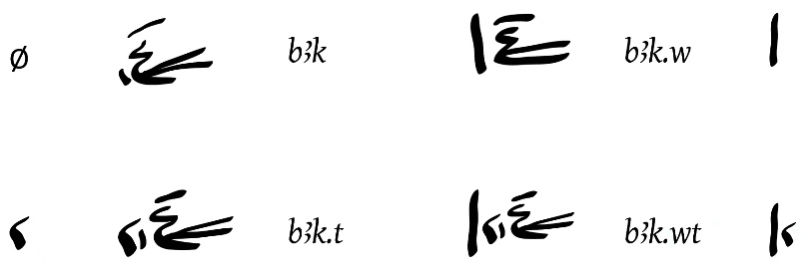

- Tolomeo: Does ⲙⲛⲧ- in Sahidic (or ⲙⲉⲧ- in Bohairic) come from md.t? Foy: Yes

- imy-r(a) from older phases of Egyptian has shortened to mr in Demotic:

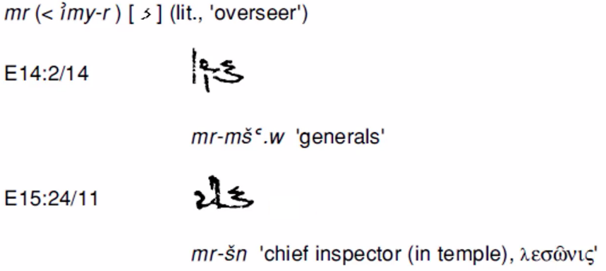

- the indirect genitive particle n became “immutable” in Late Egyptian, and similarly, does not inflect in Demotic

- Tolomeo: Could pA wab mean “the pure one” instead of “priest”? [as in Coptic…] Foy: Yes, but [to emphasize that meaning,] they would probably instead write pA nty wab

- they often leave out phonograms from the articles: e.g., the (top) n in the plural definite article nA

- in a long passage, start with what you know or what looks distinctive: e.g., the iry at the end of the first line below:

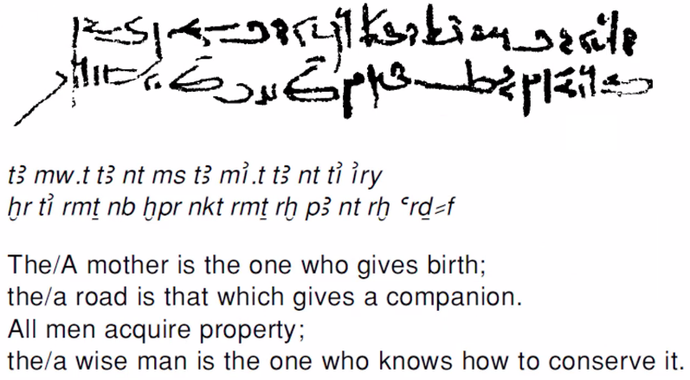

- Johnson in her grammar uses some unusual labels: dividing predicate types into verbal and “nominal” (i.e., nonverbal), and referring to the stative as the “qualitative”

- [Foy tried to explain Johnson’s “nominal” label in terms of deep structure with implicit wn’s, but I lost him: see Johnson, ⁋10]

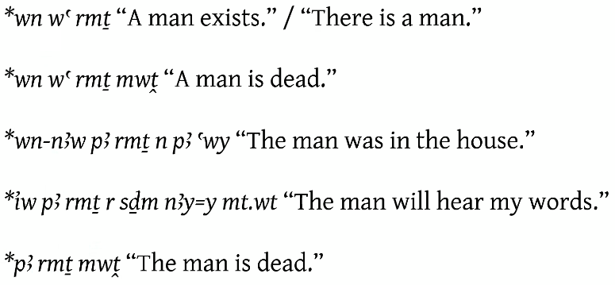

- David Vertal: Is * wn the origin of the Bohairic ⲟⲩⲟⲛ (“there”)? Foy: Yes

- in the basic nominal predicate structure, the pA/tA/nA must agree with the “A” part:

A + B + pAy/tAy/nAy

A + pA/tA/nA + B

As for A, he/she/they is/are B.

- the spellings of pAy, tAy, nAy:

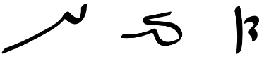

- the independent pronoun series:

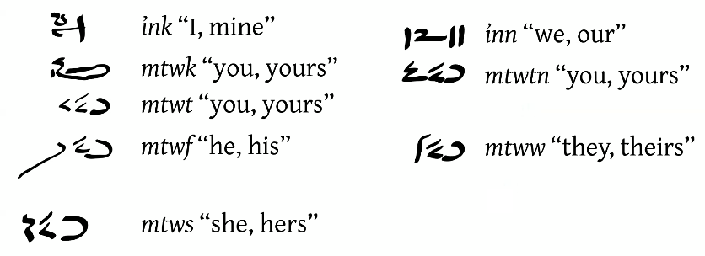

- an example of a very short, but complete, sentence with nominal predicate:

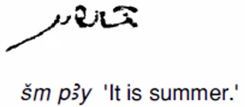

- Foy is working on a payprus where the text starts at a hole in the papyrus and the first sign after that is the “fancy eye” (Gardiner D6), which can only be a determinative of one of a very short list of possible verbs

- the word Pr-aA in actual Demotic text:

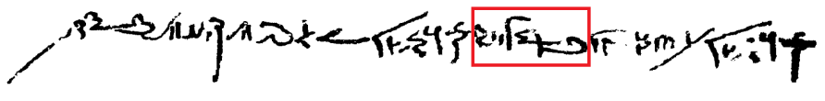

wa s# ls n Pr Pr-aA wa s# Hny pA ym pAy

A slip of the tongue in the palace [“House of Pharaoh”]: It is [like] a wrong turn of helm in the sea.

- a longer nominal predicate:

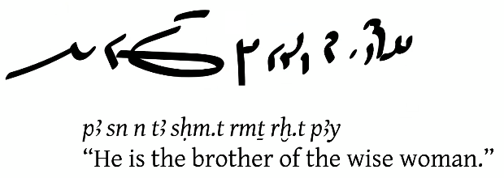

- and one for Mothers’ Day:

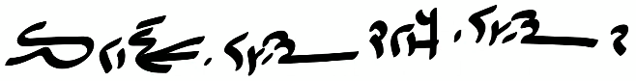

tA wp.t n mw.t tA wp.t n bAk.t tAy

The work of a mother: It is the work of a servant.

- primary forms of the sDm=f in Demotic, outside the second tense:

indicative

prospective

aorist, which is essentially just Hr + prospective, but which Johnson classifies separately

- the aorist has gnomic tense

- as in earlier phases of Egyptian, indicative forms move a narrative along:

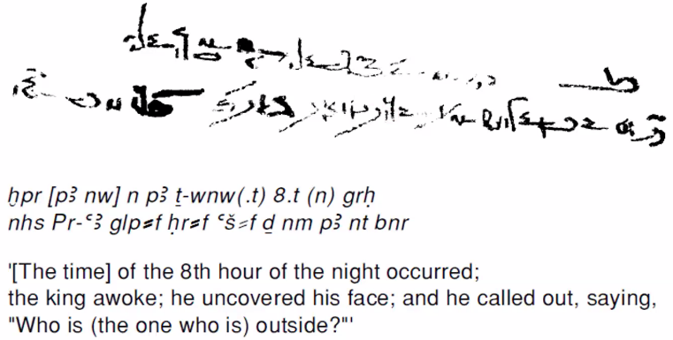

- the suffix pronoun series (from Johnson):

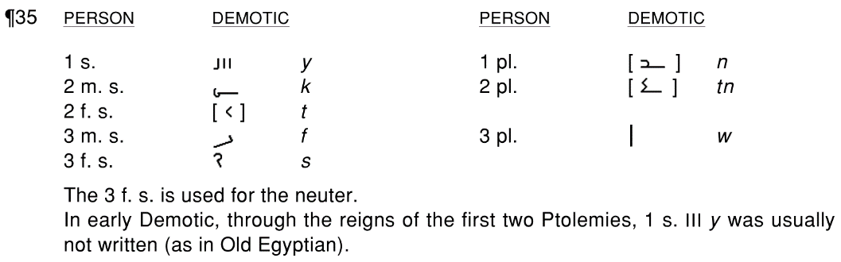

- uses of the suffix pronouns:

subject of a verbal sentence

object of a preposition

direct object after an infinitive

possessive pronoun, but only for one of a short list of inalienable body parts

- the direct object pronoun series:

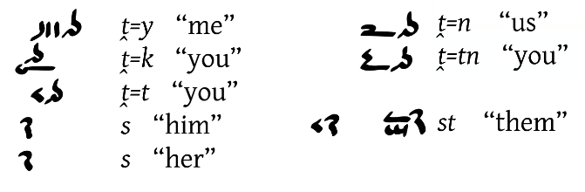

- use of direct object pronouns: direct objects following a conjugated verb or imperative

- the list of inalienable body parts:

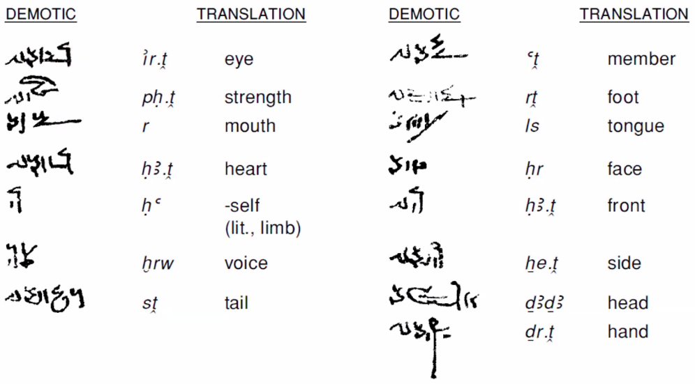

- sDm=f in Demotic:



- Demotic, like Late Egyptian, doesn’t have a separate passive-voice construction: instead uses active voice with an (impersonal) plural 3rd-person pronoun subject

**5/21/2024**

**3. The Demotic Adverb and Adverbial Phrases**

[missed most of the latter part of this class due to an airplane flight]

- examples of variation in spelling: ‘Onchsheshonqy and a few other scribes write *pr* differently

- ISACM E49083:

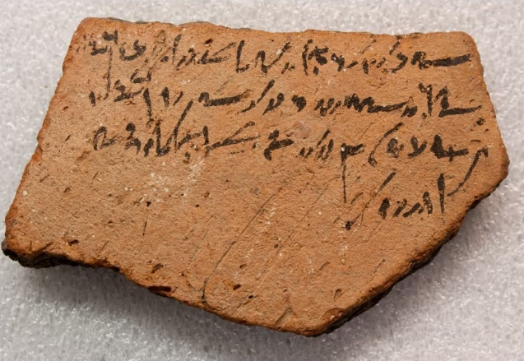

in +d-@r sA PA-Mn HD qt ½ n Hw.t-nTr n HD mr-xAs.t

rn PA-Gyr sA PA-@r r-in=f r tA xAs.t

iw=f qs sX @r-%A-As.t sA Ns-Mn Hsb.t 38

ibt 1 pr.t sw 10

Theos, son of Paminis, brought ½ silver kite to the temple for the tax of the overseer of the necropolis,

in the name of Pchoilis, son of Pauris, whom he brought to the necropolis

when he was buried. Signed Harsiese, son of Esminis, in year 38,

Tybi [“month 1”], day 10.

- “choachyte” [?]

- another ostracon (from ISACM?):

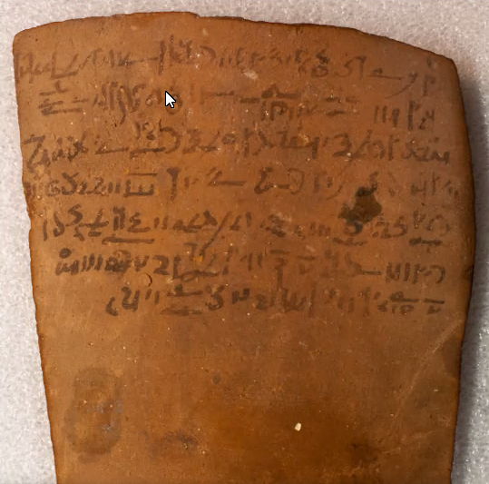

i* nTr In-Ir.t-r-r=w sA +d-@r pA nty sHn=w n Ii-m-@tp sA Ns-PAw.ty-tA.wy

sHn=y n=k pAy=y ibt n +ma n sA tpy

ibt 3 ^mw sw 13 r ibt 4 ^mw sw 13 mtw=k TAy nHH[?]

[sw (iyp.t) 20 pAy] sw mtw=k TAy pA Hnk (mnxy)[?]

mtw=k iri nAy=f Sms.(w) nAy=f arS.(w) iw bn-pw=k ti aS

m-sA=y n m* n pA tA iw ink s pA fAy

n pA ibt iw ink s pA wtbe.t

It is Inaros, son of Teos, who leased them to Imouthes, son of Espatous.

I have leased to you my month [of priestly service] in Djeme [Medinet Habu], in the first phyle,

from month 3 of Shemu day 13 to month 4 of Shemu day 13. And [continuative?] you will take the oil[?],

[…] and you will take the beer (and cloth)[?].

And you will make their services and their offerings, but you will not have a claim

against me for anything at all, for it is me to whom the income belongs

for the month, me to whom the [reversion] offerings belong.

- wAH-mw [?]

- ISACM E17481

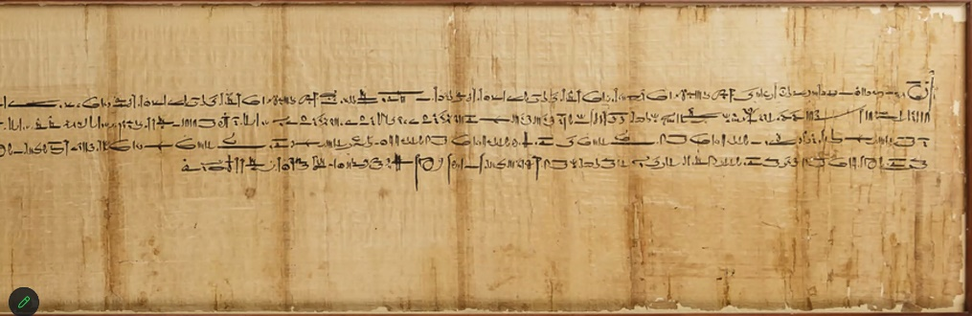

-

**5/28/2024**

**4. First Present and Third Future**

- locate the word ty (“here”)



in O. Medinet Habu 158:

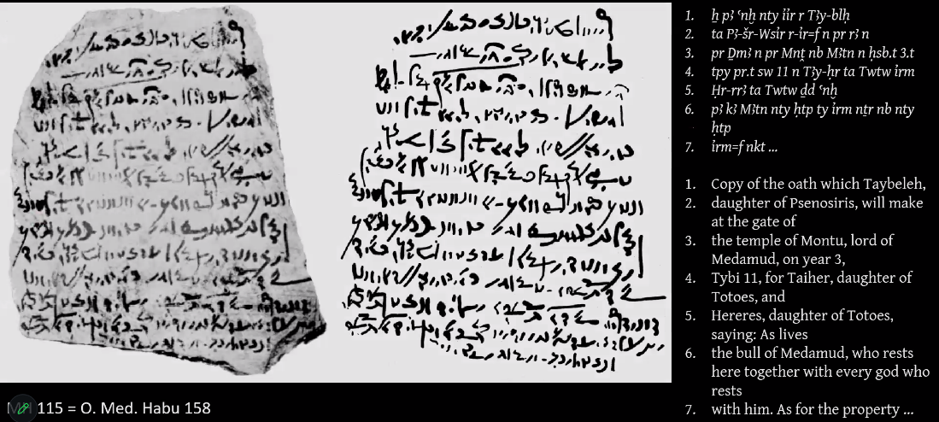

- locate the word an (“again”)



in O. Medinet Habu 72:

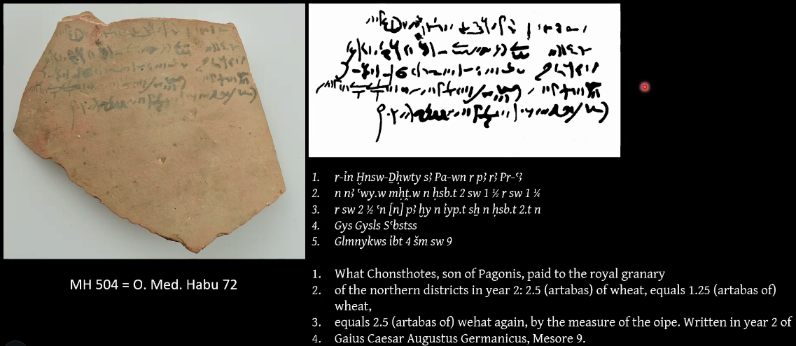

- above, note how Caesar is transcribed as Gysls as k and g had converged in Demotic

- the aorist indicates gnomic tense, and opens with xr:



xr Sms=y HAty=y

I follow my heart.

- some prepositions take different forms before different pronominal subjects (i.e., suffix pronouns):

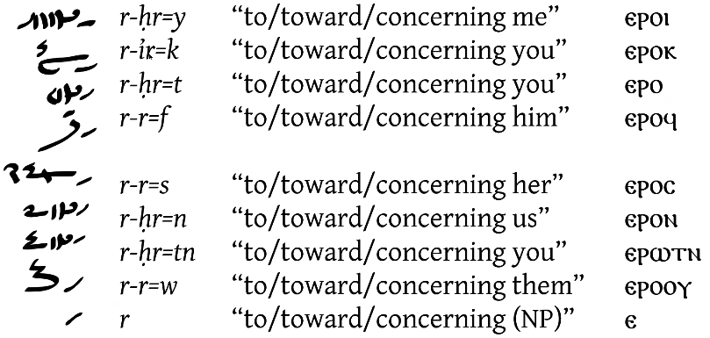

- the simple past tense expressed using sDm=f forms:

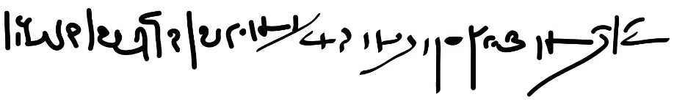

TAy=w n=f Dma

sX=f Hr nA blDa.w nA Hnw.w nA mt.w(t)

To him was brought [“They took to him”] papyrus.

He wrote the words upon the sherds of the pots.

- comparing possible translations of varying fidelity, recalling that mtw=f comes from Middle Egyptian m di=f:

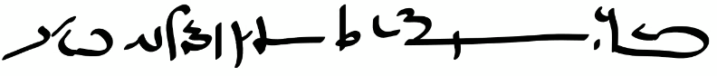

xr Sms Sr nfr i* mtw=f

A good son follows the father that he has.

A good son follows the father with him.

A good son follows his father.

- as in earlier phases of Egyptian, a pronominal direct object can move up in the word order to precede a non-pronominal subject:

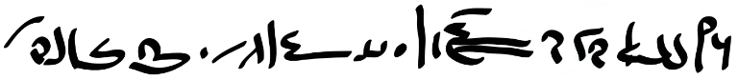

sw* st nA bAk.w n pA awy n mtr

The servants delivered it to the house at midday.

- in the example below, nH* is spelled with a sign that evolved from the nH bird biliteral:

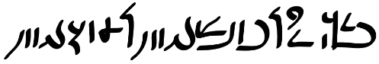

xr nH*=y HAt=y

I trust my heart.

- we know from Coptic that in Demotic, infinitives take three forms:

the absolute state, used without reliance on other words

the construct state, used before noun phrases to show a dependence (e.g., genitive or accusative)

the pronominal/pre-pronominal state, used before suffix pronouns

- the first present is a *bipartite* form:

[noun phrase] + [adverbial predicate] / [infinitive]

- example of the first present:

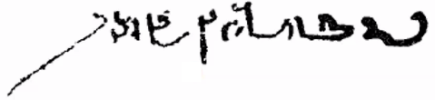

Amy.t rmT r Hr=f

The character of a man is in [“toward”] his face.

- the first present evolved from the Hr + [infinitive] pseudoverbal construction when the Hr was dropped from spoken pronunciation

tw=i Hr sDm

becoming

tw=i sDm

- the proclitic/preformative pronoun series, used in the first present for pronominal subjects:

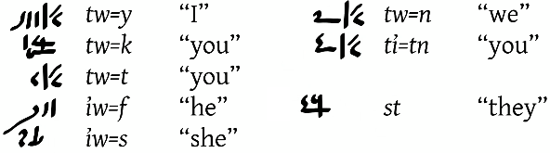

- the “durative object rule”: in durative constructions like the first present and its “satellites”, direct objects must be preceded by the preposition n / n-im when they are pronominal:

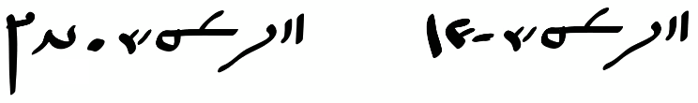

iw=f sDm n pA rmT

but

iw=f sDm n-im=w

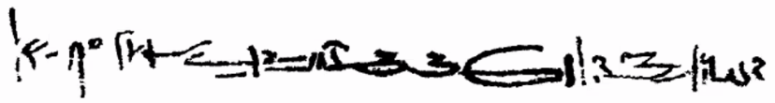

nA mt.w(t) r-wn-nAw anx-^Snqy sA *-Nfr sX n-im=w

the words that ‘Onchsheshonqy, son of Tjanefer, was writing [“them”]

- effective of transitivity on verbs in the stative:

roots with high transitivity will express action upon the subject: passive voice

roots with low transitivity will express action performed by the subject: active voice

- the stative in Demotic, like in earlier phases, fills adverbial slots, including the first present , and can also modify preceding noun phrases or clauses

- spelling differences between the infinitive (first column) and the stative and sDm=f forms (second column):

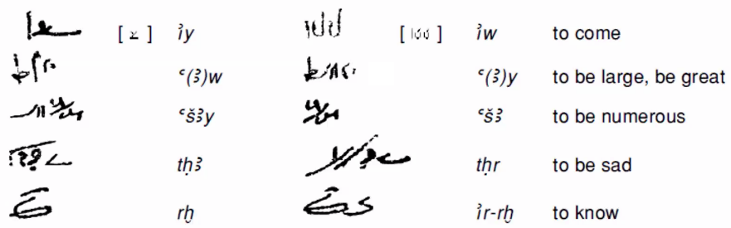

- often, we need the surrounding syntax to distinguish the stative from an infinitive:

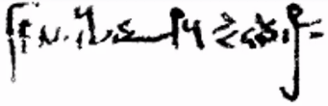

Dr.t nb swtn n pA nTr

Every hand is extended [stative] to the god.

- the third future is a *tripartite* form:

iw + [noun phrase] + (r) + [infinitive]

- when the r is omitted, the third future can look very similar to the first present, but we can often use the durative object rule to distinguish it:

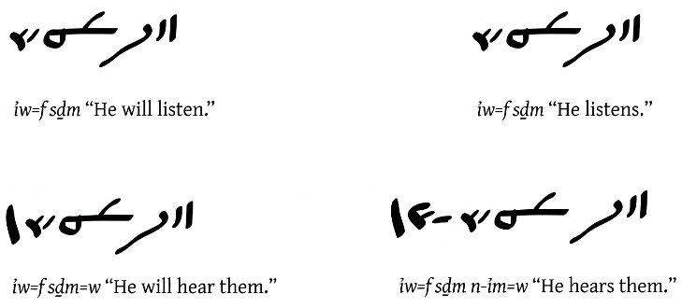

- subject pronoun series for the third future:

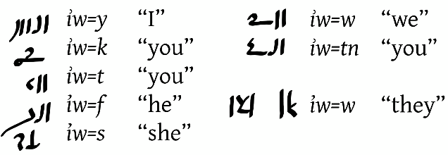

- A sample of the Demotic Palaeographical Database Project (DPDP) interface:

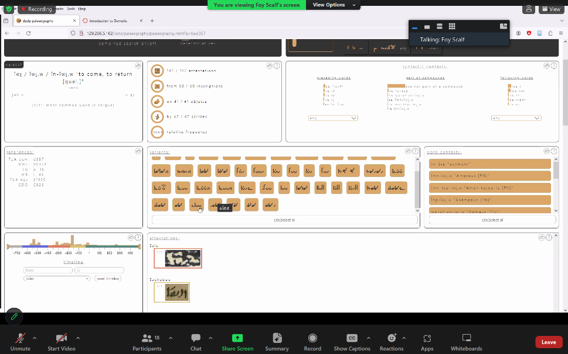

**6/4/2024**

**5. The Demotic Adjective**

-

**6/11/2024**

**6. The Imperative**

- from a contract in the Hawara papyri: the first line begins, “Year 2, day ___ of Pharaoh Ptolemy, son of …”

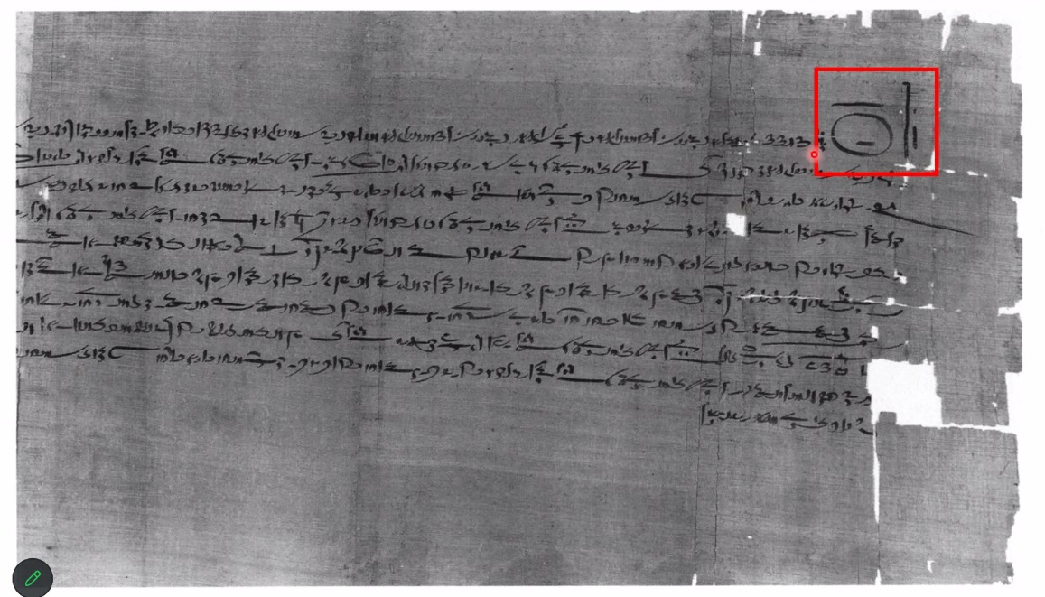

- The circled word is awy:

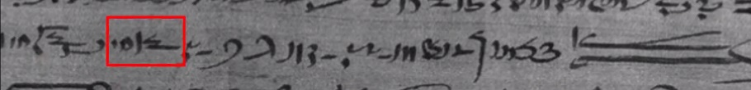

ti=k mt(r)e HAty=y n pA HD n tAy=y tny.t 1/3 n pAy awy nty qt

You caused that my heart be satisfied [prospective] with [“of”] this money for my share [of] one-third of the house that is built…

- The circled word is m-sX, meaning “written by”, “signed”, and the last word in the last line is the beginning of a name, %bk-:

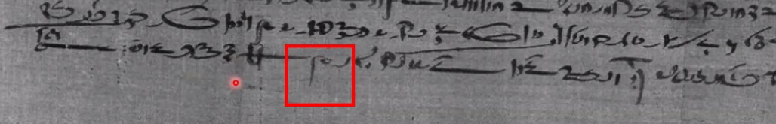

- OIP 113: *Oriental Institute Hawara Papyri: Demotic and Greek Texts from an Egyptian Family Archive in the Fayum (Fourth to Third Century B.C.)*

<https://isac-idb-static.uchicago.edu/multimedia/514/oip113.pdf>

- narrative use of the first present, translated using the English past tense:

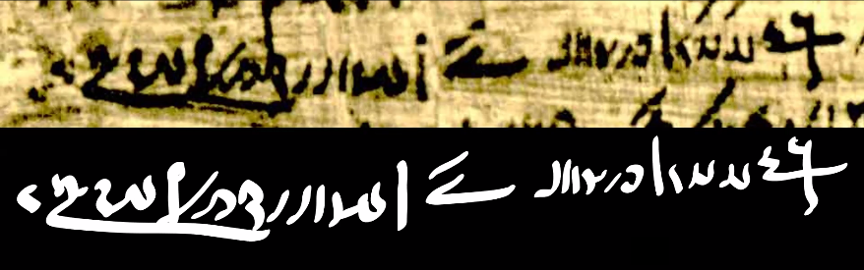

st iw m-sA=y

TAy=w *=y r tA hrw*A.t

They came after me.

They took me to the festival.

- a full sentence from the Tale of Setna I:

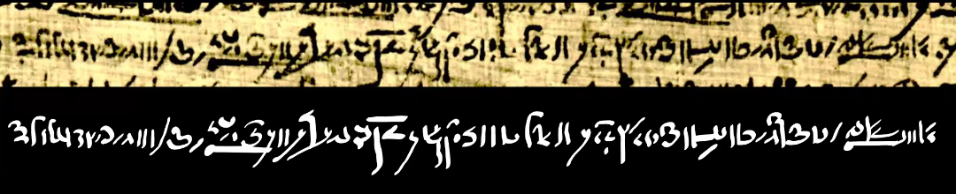

ti=y TAy=w *=k r pA mAa nty iw pAy Dma n-im=f

iw +Hwty pA iir sX=f n-Dr.*=f Ha=f

iw=f na.k r-Xry m-sA nA nTr.w

I will cause you to be taken to the place where this scroll is [“in it”],

as it was Thoth who wrote it with his own hand,

when he had come down after the gods.

- an example with two syntactically distinct translations:



ir.*=k nfr.t tAy

It is your beautiful [adjective with feminine ending] eye.

OR

Your eye is a beautiful one [abstract noun].

- third future in a contrastive construction:

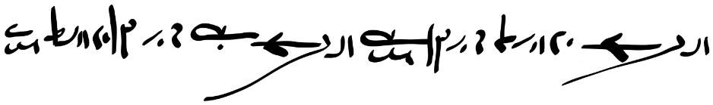

iw=f ti ay nAy=f rmT.w xm.w

iw=f ti xm nAy=f rmT.w ay.w

He will cause its small men [to be] great;

he will cause its great men [to be] small.

- the sDm=f of adjective verb in a clause with an r of comparison:

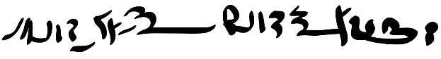

nA m-Ss tAy=s wp.t r tAy=y

Her work was more significant than mine [“was significant more than mine”].

- an example where all of the signs should be relatively easy(!):

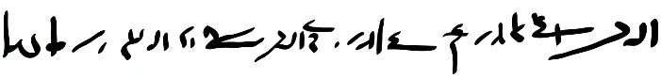

iw=f qt wa awy n tAy=f Hm.t irm nAy=f xr*.w

He will build a house for his wife and children.

- translate into Demotic in two ways: “Potsherds are more numerous than papyri.”

using the sDm=f of adjective verb:

nA-aSA blDa.w r Dma.w



using the first present(?) with wn:

wn blDa.w aSA r Dma.w

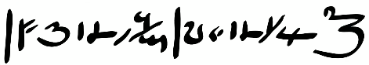

- how to identify the imperative:

found in direct speech to a 2nd-person interlocutor

no explicit subject

may be followed by dependent pronoun as object

- verbs with special imperative forms:

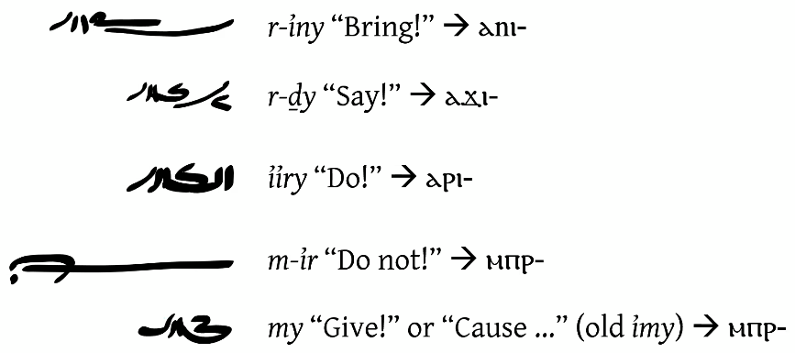

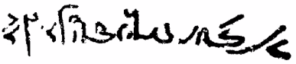

r-Dy mt.t mAa.t n rmT nb

Speak the words of truth to all men!

- the imperative my can be combined with a verb in the prospective to yield an optative:



my sDm=f



my ir=f sDm

Let him [“Cause that he”] hear…

- “yes/no” interrogatives formed by prepending



in

to any type of main clause, before the main verb:

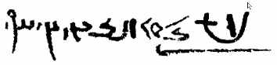

in D=k st iir-Hr rmT n pA tA

Did you tell them to anyone at all?

- proper names in Demotic are very hard: use the Demotisches Namenbuch

- the names of the major gods can just be memorized liked other vocabulary:

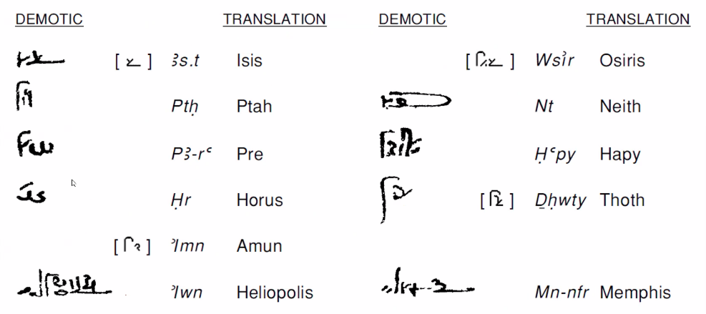

- PA-ti- and &A-ti- names:

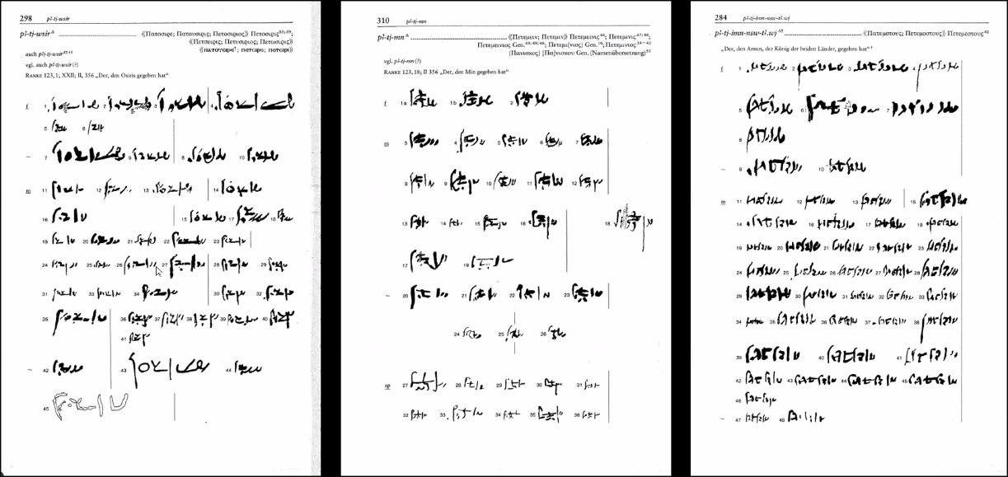

- PA-Sr- and &A-Sr.t- names:

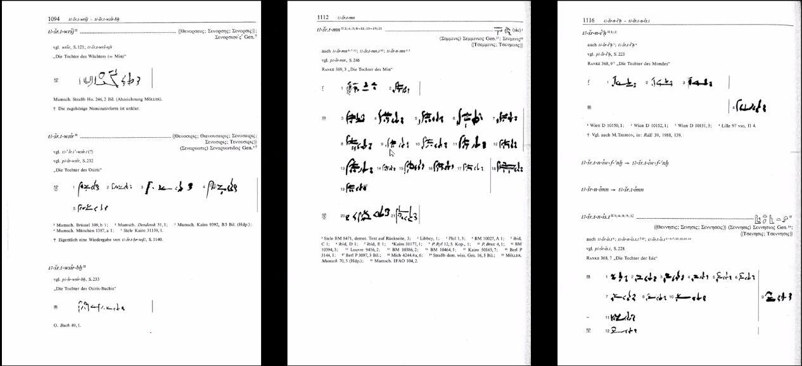

- Ns- (“Belongs-to-…”) names:

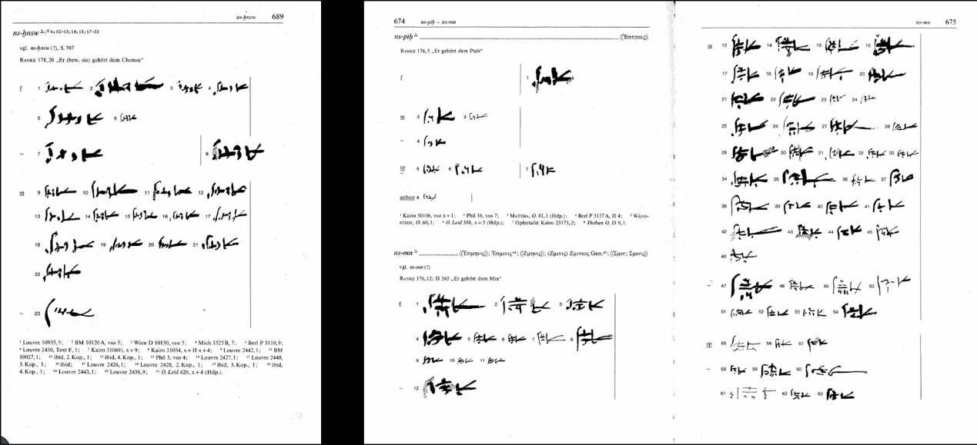

- some interjections and conjunctions in context:

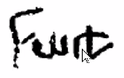

i PA-Ra

O Pre!

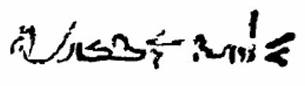

twys tA mtr.t

Here is the teaching.

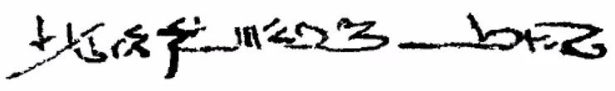

r-DbA xpr wn mtw=y wa #a (m)-Xl

…because I have a young boy

**6/18/2024**

**7. The Converters**

-

**6/25/2024**

**8.**

-